Copyright reserved

Please turn over



**NATIONAL CERTIFICATE**

**MECHANOTECHNICS N4**

**MARCH 2018**

**29**

**This marking guideline consists of 9 pages.**

**MARKING GUIDELINE**

# QUESTION 1

1.1 • FORCE APPLIED TO WRONG RING DURING MOUNTING

Care must be taken that the force required for mounting a bearing is exerted correctly. Example: The force should be applied to the inner ring when the bearing is mounted on a shaft, but applied to the outer ring when the bearing is mounted in a housing.

* MISALIGNMENT OF BEARINGS DURING MOUNTING

When a bearing is mounted with hydraulic or any other equipment, it must be ensured that the bearing is placed absolutely square and aligned before it is pressed and fitted into a shaft or into a housing. Misalignment during mounting may cause damage to the races and rolling elements of the bearing.

* MOUNTING THE HOUSING END COVER INCORRECTLY

If the housing and cover which normally pushes against the outer ring is wrongly mounted, distortion of the bearing’s outer ring occurs. This leads to bearing failure.

* MOUNTING BEARINGS IN A DAMAGED HOUSING OR SHAFT

Bearings should never be mounted on a damaged or worn shaft or worn housing since this may cause the inner or outer ring to start creeping, thus reducing the effectiveness of the bearings. Movement or creep can also damage the bearings' seats.

* MOUNTING BEARINGS THE WRONG WAY ROUND

Some bearings, for instance single-row angular contact bearings, can carry loads in one direction only. If these bearings are mounted the wrong way round, the bearing may be forced apart or the balls may be damaged, leading to early bearing failure.

* EXCESSIVE LUBRICATION

Too much grease forced between the rolling elements of bearings can cause just as much damage as insufficient lubrication. Too much grease results in rapid heating which will be detrimental to the effective working of the

bearings.(Any 5 × 2) (10)

1.2 • SURFACE CORROSION

Surface corrosion is caused by either a chemical reaction or an electrochemical process.

* STRESS CORROSION

This type of corrosion usually occurs in metals subjected to welding, cold- welding or forming.

* GALVANIC CORROSION

Galvanic corrosion takes place when two dissimilar metals come into contact with each other or when they are electrically joined.

* INTERCRYSTALLINE CORROSION

Some alloys, especially stainless steel have an uneven structure caused by the heating and cooling processes to which they are subjected.

* PITTING CORROSION

This form of corrosion is recognised by the appearance of little holes or pitting marks on the metal surface. It is an example of a non-uniform corrosion which develops due to the unevenness in the structure of the metal. (5 × 2)(10)

1.3 • Regulation of local authority

* The required volume of work
* Inspection requirements to be met • The quantity of material required
* Volume of final product to be manufactured • Sequence in which production has to take place

* Type and quantity of equipment needed

* By-products and waste products which may cause pollution

* The most effective flow routes for the proposed type of production

* Type of production required e.g. mass batch or individual production

* Available storage place
* Any additional services which are available, for example water, gas, sewerage and electricity • The types of handling equipment to be used • The type and quantity of the available workforce and level of skill of these

workers (Any 10 × 1) (10)

**[30]**

# QUESTION 2

2.1 π. .*D N*  *v* =

60

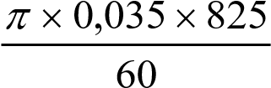 =

=1,512 *m s*/  (2)

2.2 *TC* = *mv*2

= 0,98(1,512)2 

= 2,24 *N*  (2)

2.3 *Po*

*Pi* =η

3

35×10

*Pi* = 

0,79

= 44,304 *kW*  (2)

2.4 *T*1 −*TC* µθ αcos*ec*

= *e*

*T*2 −*TC*

740 − 2,24 0,3× 3,281× 2,924

= *e* 

*T*2 − 2,24

737,76

=17,78

*T*2 −2,24

737,76 =*T*217,78−39,827

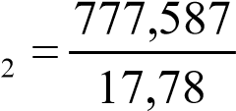  *T*

∴ =*T*2 43,43734 *N* ∴ =*T*1 740 *N*  (6)

2.5 *P*

(*T*1 −*T n*2 ) = *v*

35×103

(740 − 43,734)*n* =

1,512

23148,148

*n* =

696,266

= 33,25  *say n* = 33

(2)

# [14] QUESTION 3

3.1  *Ff* =µ*xmxg*

*Ff* = 0,2 ×100 ×9,81

=196,2 *N* 

*WD f* = *Ff* × *Sl*

=196,2 × 0,25

= 49,05 *J*  (3)

3.2 *WDtotal* =*WDcutting* +*WDfriction*

*WDcutting* =*WDtotal* −*WDfriction*

=125 − 49,05

= 75,95*J* 

*WDcutting*

*Fcutting* =

*Sl*

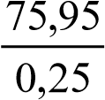 *Fcutting* =

= 303,8 *N*  (3)

1 000 N

3.3

B

A

40

40

50

303,8 N

*Take moments about B to find A*

∑*CWM* =∑ *ACWM*

*A*× 80 = (303,8×130) + (1000 × 40) 

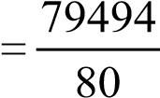  *A*

= 993,675 *N* 

*Take moments about A to find B*

∑*CWM* =∑ *ACWM*

1000 × 40 = (303,8×50) + (*B* ×80)

*B* 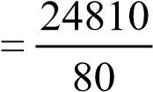

|  |  |  |  |
| --- | --- | --- | --- |
| = 310,125 *N*  | |  | (8) |
| **QUESTION 4** | |  | **[14]** |
|  |  |
| 4.1 | STEP 1    Draw up the arrangement on a sufficient large scale to show clearly all the measurements.    STEP 2    Construct the right-angled triangle from the given measurements.    STEP 3    Calculate the angle from the right-angled triangle and then find the magnitude of the included angle. |  | (3) |

4.2

4

,25

R

36

,75

30

h

r

20

Sketch =







(3)

4.3 B

θ

A

C

*BC* = −*R r*

=15−10 

= 5 *mm*

*AB in ABC*

*AB* = (36,75+10)−(15+ 4,25)

= 46,75−19,25

= 27,5 *mm* 

*BC*

*Sin*θ=

*AB*

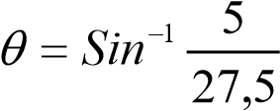 

=10,476°

∴*included angle* = 2θ

= 2 ×10,476

= 20,952° (8)

# [14] QUESTION 5

5.1 *PCDA*

*TA* =  *m*

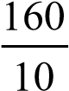

=

=16 *teeth*

*TB* 3

=

*TA* 2

3*TA*

*T* =

*B*

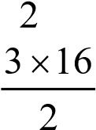

*TB* =

*TB* = 24 *teeth* (4)

5.2 *Addendum* = *m*

=10 *mm* 

*Dedendum* =1,157 ×*m*

=1,157 ×10

=11,57 *mm* (2)

5.3 *DOA* = *m T*( *A* + 2)

=10(16 + 2)

=180 *mm* 

*DOB* = *m T*( *B* + 2)

=10(24+ 2)

= 260 *mm* (2)

5.4 *PCDB* =*m T*× *B*

=10 × 24

= 240 *mm* (1)

5.5 *Totaldepth* = *Aaddendum* + *Ddedendum*

=10 +11,57

= 21,57 *mm* (1)

5.6 *C p* =π× *m*

=π×10

= 31,416 *mm* 

*Cp*

*Tooththickness* =

2

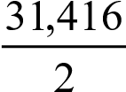 *Tooththickness* =

=15,708 *mm* (4)

**[14]**

# QUESTION 6

6.1 *vt* = 2*gh*

= 2 × 9,81× 4,5 

= 9,396 *m s*/ 

6.2 *va* =

*y*

*gx*

2

2

2

0,327

9

,

81

(2,15)

2

×

×

=

= 8,327 *m s*/ 

6.3 *Qt* = *vt* × *At*

1. π(0,052)

= 9,396 × 

1. 4

= 0,02 *m* / *s* 

6.4 *Qa* = *va* × *Aa*

* + 1. π(0,041)

= 8,327 × 

* + 1. 4

= 0,011*m* / *s* 

* 1. *Qa*

*Cd* = *Qt*

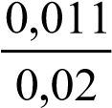 =

= 0,55

* 1. *va*

*Cv* = *vt*

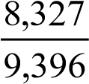 =

= 0,866 

* 1. *Cd*

*Cc* =

*Cv*

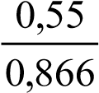 =

*= 0,635*

(7 × 2) **[14]**

# TOTAL: 100